**Tribhuvan University**

**Faculty of Management**

AN

**INTERNSHIP REPORT**

ON

Title Page

**“Junior Java Developer Internship at Next Step”**

**Submitted to Department of Information Technology**

**NIST COLLEGE**

**August 2023**

***In partial fulfillment of the requirements for the Bachelors in Information Management***

**Submitted by**

**Mona Bhandari**

**TU Roll No: 9527/18**

**(TU Regd No. 7-2-1014-8-2018)**

**Under the Supervision of**

**Mr. Samish shrestha**

Declaration of Originality

I hereby declare that the internship report entitled “**Junior Java Developer Internship at Next Step**” submitted to Office of the Dean, Faculty of Management , Tribhuvan University, Banepa is my original work accomplished under the supervision of **Mr. Samish Shrestha** for the fulfillment of the requirement for the Bachelor Information Management (BIM). This work is an independent work and any help taken from the other people has been mentioned in acknowledgment.

**Mona Bhandari , VIII Semester**

**TU Roll No: 9527/18**



Supervisor’s Recommendation

I hereby recommend that this internship report prepared under my supervision by **MONA BHANDARI** entitled “**Junior Java Developer Internship at Next Step**” in partial fulfillment of the requirements for the degree of Bachelor in Information Management is recommended for the final evaluation.

_________________________

Mr.Samish Shrestha

SUPERVISOR

Instructor

Department Of Information Technology, Nist College

Banepa-9, Nayabasti Nala, Kavrepalanchok

Mentor’s Recommendation

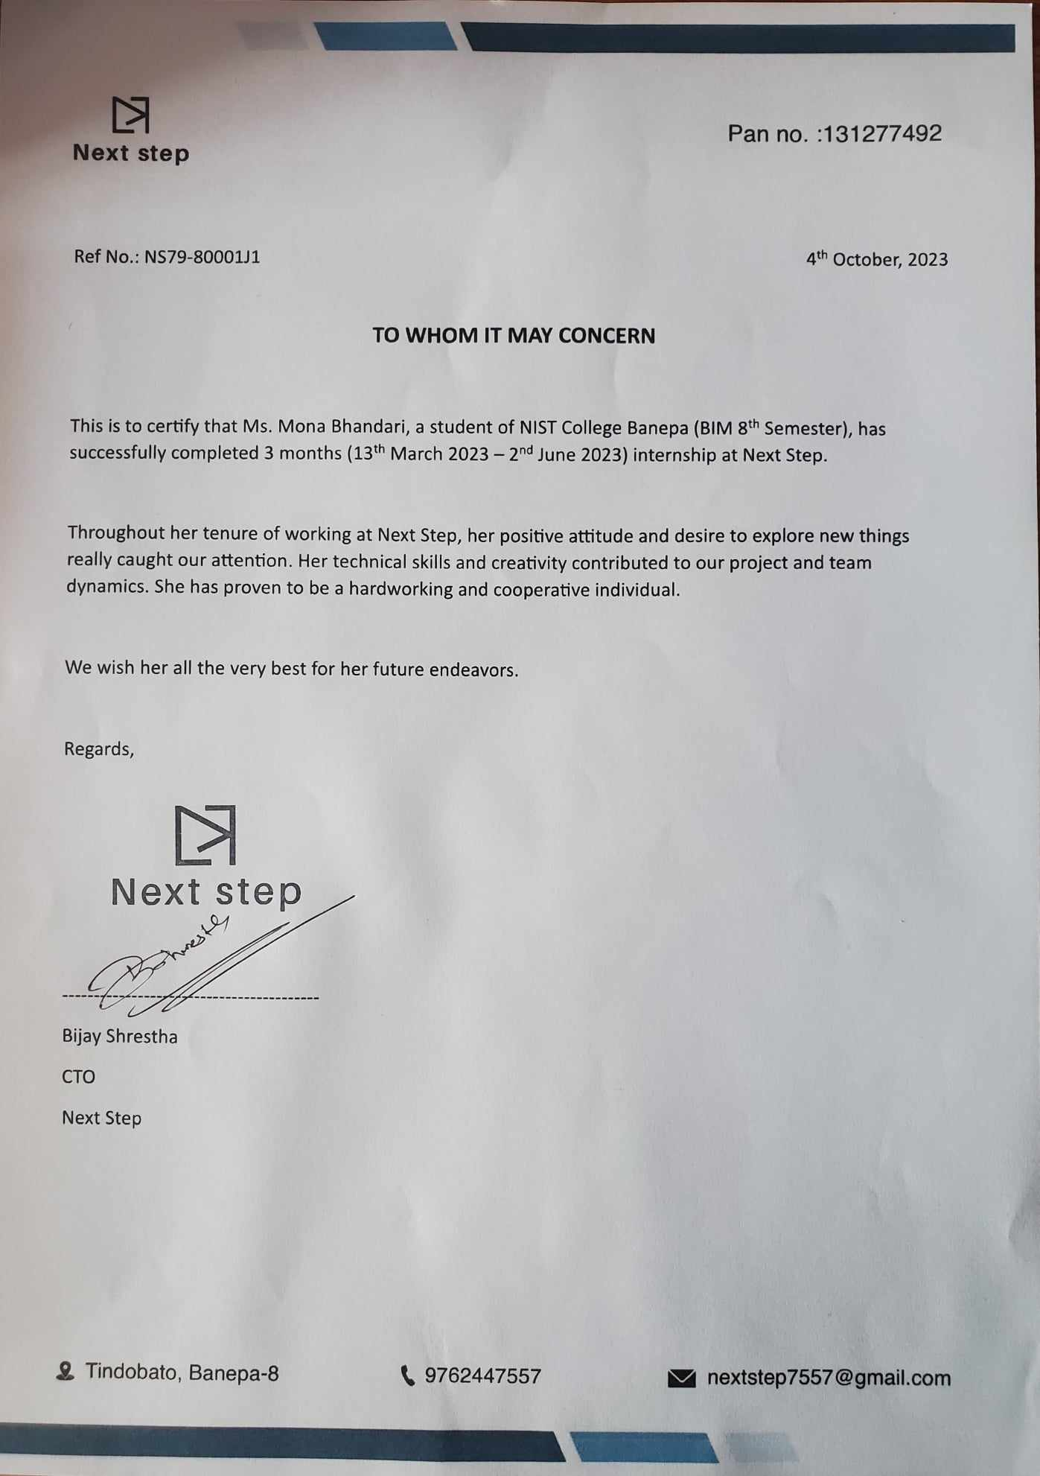

Letter of Approval

This is to certify that this report prepared by **Mona Bhandari [9527/18]** entitled “**SPRING FRAMEWORK**” in partial fulfillment of the requirements for the degree of Bachelor in Information Management has been evaluated. In our opinion it is satisfactory in the scope and quality as a project for the required degree.

|  |  |
| --- | --- |
| …………………………......  **Mr. Samish Shrestha**  Supervisor  Instructor, Department Of Information  Technology, Nist Banepa  Banepa-9,Nayabasti,  Kavrepalanchok | ………………………………..  **Mr. Yubraj Neupane**  Internal Examiner  Department Of Information Technology,  Nist Banepa  Banepa-9,Nayabasti,  Kavrepalanchok |

ACKNOWLEDGEMENT

I would like to express my sincere thanks to the Department of Information Technology, Nist College for providing me with this opportunity to explore my thoughts, curiosity and interest in the field of computer science through a Final Year Internship “**Junior Java Developer Internship** **at Next Step**".

I am glad to take this opportunity to express my sincere gratitude and sincere thanks to our highly respected and esteemed guide **Mr.Samish Shrestha**, Nist College, for his valuable guidance, suggestion, encouragement, critical comment and help for completing this work. His constant support and motivation always encouraged me. My thanks to him will always be counted.

I would like to express my deepest sense of gratitude to my highly respected and esteemed mentor **Mr. Bijay Shrestha,** CTO **,Next Step.** for providing me a golden opportunity for completing my internship at their reputed organization. I would also like to thank Next Step for providing a wonderful and friendly environment to work in. Their useful suggestions for this whole work and cooperative behavior are sincerely acknowledged.

In addition, I extend my sincere thanks to my friends, seniors and guardians for their direct/indirect contribution in this project and helping me to bring this project into existence. I will be always looking forward to hearing the comments. Suggestions for further improvement will be highly solicited.

Sincerely,

**Mona Bhandari**

**TU Regd No: 7-2-1014-8-2018**

ABSTRACT

An internship opportunity as a Web App Developer with the title "Junior Java Developer" was undertaken at the organization "NEXT STEP," situated in Banepa-9, Kavre. The primary objective of this internship was to acquire practical experience in the development of web applications designed for browser-based usage. This internship provided a distinctive chance to gain hands-on expertise in creating robust and responsive web applications using the Spring framework. The learning process encompassed the utilization of Spring ORM, APIs, and various tools for the design, construction, and deployment of web applications.

In line with the internship's objectives, the assignment was centered around a project called "Bagmati Tipper," a Vehicle Registration system that facilitates the addition of vehicles and their installment payments via an internet connection. Within this project, responsibilities included crafting diverse user interfaces such as the login page, vehicle registration, and form validation. These tasks were accomplished successfully under the guidance of the organization's mentor. Additionally, active participation in code reviews and contributions to real-world web application development were integral components of the internship. By the conclusion of the internship program, a solid comprehension of Spring's capabilities had been acquired, positioning oneself favorably for a future career as a web app developer.

On the whole, this internship experience furnished invaluable insights into the realm of quality assurance and facilitated the acquisition of essential skills in data analysis, project management, and collaborative teamwork. Confidence is held that the enhancements made during the internship will have a lasting impact on the company's operational efficiency. The knowledge and skills acquired will be applied to future web app development projects with enthusiasm.

Keywords: web applications, spring framework

Table of Contents

Table of Contents

Title Page i

Declaration of Originality ii

Supervisor’s Recommendation iii

Mentor’s Recommendation iv

Table of Contents iii

List of Tables v

List of Figures vi

List of Abbreviations vii

Chapter 1: Introduction 1

1.1 Introduction 1

1.2 Problem Statement 1

1.2.1 Problem statements of the project I worked during Internship 2

1.3 Objectives 2

1.4 Scope and Limitation 3

1.4.1 Scope 3

1.4.2 Limitation 3

1.5 Methodology 4

1.5.1 Organizational Selection 4

1.5.2 Placement 4

1.5.3 Duration 5

Table 1:Internship Duration 5

1.5.4 Activities 5

Chapter 2: Introduction to Industry 7

2.1 Introduction to Information Technology(IT) Industry 7

2.2 History of IT in Nepal 7

2.3 Scope Of IT 8

2.4 Opportunities in the Nepali IT Industry 8

2.5 Challenges of the IT Industry in Nepal 9

Chapter 3: Introduction to Organization 10

3.1 Organization Details 10

3.2 Organizational Hierarchy 10

3.3 Working Domains of the Organization 11

3.4 Description of intern Department/Unit 12

3.5 Mission of Next Step 13

3.6 Vision of Next Step 13

Chapter 4: Internship of the Organization 14

4.1 Role and Responsibilities 14

4.2 Weekly Log 15

4.3 Description of the project involved during Internship 17

4.3.1 Introduction to Project 17

4.3.2 System Design 17

4.3.3 Tools and Technologies Used 18

4.4 Tasks/Activities Performed 19

Chapter 5: Conclusion and Learning Outcomes 21

5.1 Conclusion 21

5.2 Learning Outcomes 21

References 23

Appendix a

List of Tables

*Tab*le 1 :Internship Duration 5

List of Figures

Figure 1:NextStep Organization Structure 11

Figure 2:Bagmati_Tipper WebApp a

Figure 3:Installment page a

Figure 4:Installment FillOut page b

Figure 5:DataBase For Installment b

Figure 6: Postman(GET)Method c

Figure 7: Postman(POST)Method c

Figure 8: Postman(DELETE) Method d

Figure 9: :Postman(Put)Method d

Figure 10: Ngrok e

Figure 11: Quiz getting started with Loader( Demo Project ) e

Figure 12: :Quiz started f

Figure 13:Final result of quiz f

List of Abbreviations

API - Application Programming Interface

BIM - Bachelor in Information Management

JSON - JavaScript Object Notation

JPA - Java Persistence API

MVC - Model View Controller

UI - User Interface

# Introduction

## Introduction

Bachelor in Information Management (BIM) is a four-year bachelor's degree course offered by TU which is a blend of Information Technology (IT) 60% and Management 40% and provides students with knowledge of IT and management concepts required in an organization. BIM is a semester system course that is divided into eight semesters and has 126 credit hours. The objective of the BIM Course is to produce quality IT professionals with managerial skills.

An internship program is a program in which a student or learner gets professional work experience under supervision. The internship is a wonderful opportunity for students to implement their knowledge into real-world projects and experiences and also an opportunity to learn about how an organization operates, how work is performed in teams and organizations, and get real-world professional experience.

This report has been prepared based on my internship experience of 3 months in Next Step. During the internship period I got real-world professional experience in frontend development, learned organizational culture, and applied learned knowledge gained in my college. Overlay this internship has helped me to improve as a person.

## Problem Statement

There is a big gap between Industry and Academia. This gap refers to the mismatch between the skills and knowledge taught in academia and those needed by the industry. In other words, there is often a disconnection between what is being taught in universities and what is expected in the workplace.

One of the main reasons for this gap is that universities often focus on theoretical knowledge and research, while industries require practical and applied knowledge. Students who graduate from universities may have a strong theoretical understanding of their field, but they may lack the practical experience and skills that are needed to excel in the workplace. As a result, employers may have to spend additional time and resources training new employees, which can be costly.

Another factor that contributes to the gap between industry and academia is the pace of innovation and technological advancements in the industry. Universities often take several years to update their curricula to reflect the latest trends and technologies, whereas the industry moves at a much faster pace. This means that students may be learning outdated information, which can hinder their ability to succeed in the workplace.

To bridge this gap, there needs to be better collaboration between academia and industry and one of the most reliable way is to offer internship opportunities to students which ensures that students are equipped with the skills and knowledge they need to succeed in the workplace, and that the industry has a skilled workforce that can drive innovation and growth.

### 1.2.1 Problem statements of the project I worked during Internship

* Most of the information is collected through personal experience and observation; the overall information may not be presented.
* General knowledge about OOP, java and JavaScript is mandatory in spring framework which consumes much time. So it slightly hampered the main subject of internship.

## Objectives

The main objective of this internship are stated below:

* To implement the academic knowledge into practical area.
* To get familiar with corporate culture and the real working scenarios.
* To collaborate and exchange ideas with professionals and to learn and use prevailing tools and technology.

The general objective of project done during internship is

**•** To enhance the Bagmati Tipper system's security and ensure the accuracy of data

## Scope and Limitation

### Scope

The scope of this internship is to gain a learning and web app development experience while also providing value to the organization through my contributions.

#### Some of the major scopes of project done during internship includes:

* Time-Saving Automation: One of the core objectives of the Bagmati Tipper System is to save users' time by automating various tasks related to tipper operations. Through efficient data synchronization, automated billing processes, and real-time route optimization, the system streamlines operations, enabling users to allocate their time to more critical tasks.
* Security Measures: Security is a paramount concern in the Bagmati Tipper System. The system implements robust security features to ensure that sensitive data, such as financial transactions, vehicle information, and user profiles, remain protected.

### Limitation

* The report is limited by the time frame of the internship program.
* The scope of the projects assigned to me during the internship may not have provided a comprehensive view of the company's overall operations.
* It was not possible to gather the information regarding the system more specifically due to organizations privacy policy.

#### Some of the major limitation of project done during internship includes:

* Innovation Pressure: With many organizations and individuals competing to create unique and innovative solutions, interns might feel pressured to deliver something extraordinary, which can add stress and sometimes lead to unrealistic expectations.
* Pressure on Outcomes: The competitive landscape might lead to a focus on outcomes rather than learning. While striving for excellence is essential, interns should also remember that the primary goal of an internship is to learn and gain experience.

Despite these limitations, this report aims to provide a comprehensive and informative overview of my working as an intern at Next Step and my experiences and achievements within the program.

## Methodology

### Organizational Selection

Choosing the right organization for my project is a pivotal step in ensuring its success. The organization selected significantly influences the learning journey and exposure to real-world applications of backend Java development skills. Given a strong inclination towards backend development, it was imperative to find a company where the passion and expertise could be effectively harnessed. Consequently, collaboration with Next Step as the organization for the project was chosen.

In the process of selecting the company for the project, a thorough search for IT companies in close proximity to the location was undertaken. During this exploration, Next Step, an organization actively seeking a backend Java developer for an internship, was discovered. Eager to align interests with a meaningful opportunity, the CV was submitted, an interview was conducted, and the internship position at Next Step was successfully secured.

### Placement

At Next Step, a placement as a Junior Java Backend Developer was secured, providing the opportunity to immerse oneself in backend development, gain valuable insights into the organization's work culture, and become familiar with their operational processes. Over the course of three months, the supervision was provided by Mr. Bijay Shrestha.

Prior to the placement, a comprehensive interview process was conducted by Mr. Bijay Shrestha, assessing qualifications and suitability for the role. This rigorous interview ensured a well-matched placement and set the stage for a productive and enriching internship experience at Next Step.

### Duration

Table 1:Internship Duration

|  |  |
| --- | --- |
| Start Date | 13th March2023 |
| End Date | 2th June 2023 |
| Position | Junior Java Developer |
| Working Hours | 8 hours a day |
| Office Days | Monday- Friday |

### Activities

During the internship at Next Step as a Junior Java Backend Developer under the supervision of Mr. Bijay Shrestha, diverse and enriching activities were undertaken that allowed for the application of skills and contributions to the organization's projects. Some of the key activities during this period included:

* Collaborated with project teams to gather and analyze requirements for various backend development tasks.
* Participated in the design phase of web applications, ensuring user-friendly and visually appealing interfaces.
* Evaluated and analyzed the performance and functionality of the current frontend systems, proposing improvements and optimizations where necessary.
* Developed interactive quizzes using Swing, a Java GUI toolkit, to enhance user engagement and interactivity in the applications.
* Engaged in backend development projects using Spring MVC, contributing to the development and maintenance of critical systems.

The tools and technologies used for performing these activities are as follows:

1. **Integrated Development Environments (IDEs):**

* STS (Spring Tool Suite): Used for Java and Spring development, providing tools for building, testing, and deploying Spring applications.
* IntelliJ IDEA: An integrated development environment for Java, widely used for its robust features and support for various Java technologies.
* Eclipse: An open-source IDE that is commonly used for Java development and offers a wide range of plugins for different technologies.

1. **Database Management:**

* XAMPP: A popular open-source package that includes Apache, MySQL which I used for database management and development

.

1. **API Testing:**

* Postman: A widely-used API testing tool that allows for the testing of RESTful APIs, enabling efficient API development and debugging.

# Introduction to Industry

## 2.1 Introduction to Information Technology(IT) Industry

The Information Technology (IT) industry is a broad and dynamic sector that revolves around the use of computers, software, hardware, networks, and electronic systems to create, process, store, transmit, and manage information. It encompasses a wide range of activities, from developing software applications to managing complex computer networks, providing IT support, and designing advanced technologies that shape the digital landscape we interact with daily.

In recent years, the IT industry has experienced rapid globalization, with technology companies operating on a global scale and collaborating across borders to develop innovative solutions. This industry's growth has been further accelerated by the increasing demand for digital transformation in businesses, the expansion of e-commerce, and the proliferation of mobile devices.

The Information Technology (IT) industry plays a crucial role in today's world by providing digital services, transforming traditional technologies, and making our life easier through technological innovations. The IT industry is growing at a rapid pace as multiple sectors are being digitized and the digital literacy of people is being increased.

## 2.2 History of IT in Nepal

The revolution of the IT Industry has a long history and has seen vital changes from the transformation from Mainframe Computers to Personal Computers and communication from telephone to email. Similarly, IT in Nepal has its history. A brief history of IT in Nepal is listed below.

* 1961 AD (2018 BS) – “Facet” electronic calculator was used for census calculation.
* Telephone Service Exchange was established by NTC in 1960 in Kathmandu Valley.
* 1971 AD (2028 BS) – “IBM 1401, a second-generation computer” was used for census calculation.
* Mercantile Communications in 1995 started Internet Service for the 1st time.
* The 2000s: Growth in software companies, emphasis on software exports, challenges including infrastructure limitations and skilled manpower shortage.
* 2008: Nepal introduces National IT Policy to promote IT business, attract foreign investment, and boost IT education.
* The 2010s: Outsourcing opportunities rise, startup ecosystem develops, tech incubators and accelerators established.
* 2015: Earthquake impacts various sectors, IT industry contributes to disaster relief through software development.
* The 2020s: COVID-19 accelerates remote work adoption, creating new opportunities for IT professionals and freelancers

## 2.3 Scope Of IT

IT Industry is an industry that consists of multiple sub-industries like hardware, software, artificial intelligence, cybersecurity, networking, etc. IT industry has various roles ranging from developing hardware and software to technical support. As the use of digital devices is growing and IT is being integrated into many industries, the IT industry is growing at a fast pace and the scope of the sector is also evolving. The multiple career options available in the IT industry are listed below.

* Software Developer
* Ethical Hacker
* Artificial Intelligence Engineer
* Project Manager
* Network Manager
* UI/UX Designer

## 2.4 Opportunities in the Nepali IT Industry

TheNepali IT Industry has immense opportunities which are listed below

1. Outsourcing :Nepal has enormous potential for becoming an outsourcing hub due to its skilled workforce and cost-effective workforce. IT Industry majorly works by outsourcing work and many companies look for outsourcing destinations for their work so Nepal's IT Sector can capitalize on the Outsourcing demand.
2. Young and Educated Workforce :Nepal has a significant population of young and educated individuals. With proper training and skills development, this workforce can be utilized and can contribute to IT Industry’s growth.
3. Freelancing and Remote Work: With the global trend towards remote work and freelancing, Nepalese IT professionals have the opportunity to work for international clients without geographical limitations.
4. Digital Services :The adoption of digital services is increasing in Nepal. There is a growing demand for web and mobile applications, digital marketing, e-commerce platforms, and more.

## 2.5 Challenges of the IT Industry in Nepal

Nepal's IT Industry also has multiple challenges that hinder the growth of the IT Industry. The challenges of the IT Industry in Nepal are listed below.

1. Infrastructure

Inadequate physical and digital infrastructure, including reliable electricity and high-speed internet connectivity, can hinder the growth of the IT industry.

1. Regulations and Policies

The regulatory environment in Nepal might not be entirely conducive to the growth of the IT industry. Unclear or outdated regulations can pose challenges for startups and technology companies.

1. Access to Funding

Despite the growing interest in startups, accessing funding, especially venture capital, can be challenging in Nepal. Limited investment opportunities can impede the expansion of promising startups.

# Introduction to Organization

## Organization Details

During the internship at Next Step, the privilege of being part of an amazing organization located in Banepa, Tindobato, was experienced. It's a place that strongly encourages learning and creativity. At Next Step, experts in various technologies are present. React is used for making websites, Java and Node.js for backend development, and they're into mobile app development using Flutter, Kotlin, and Java. They're also skilled in computer graphics. The internship experience at Next Step was both educational and exciting, as the opportunity to learn and work with these versatile technologies in a supportive and dynamic environment was provided.

## Organizational Hierarchy

NextStep follows the functional organization structure, begins at the top with the roles with the highest degrees of responsibility and descends from there. Primarily, personnel are mostly arranged in accordance with their unique skills and the relevant role inside the organization. Each separate department is managed independently. When operating continuously in a stable environment, this structure performs well. A functional structure aims to gather all the information and human resources required for one activity in one location. Employee loyalty to their department and the company as a whole is more likely. Because there is more job security, this boosts morale and work ethic.

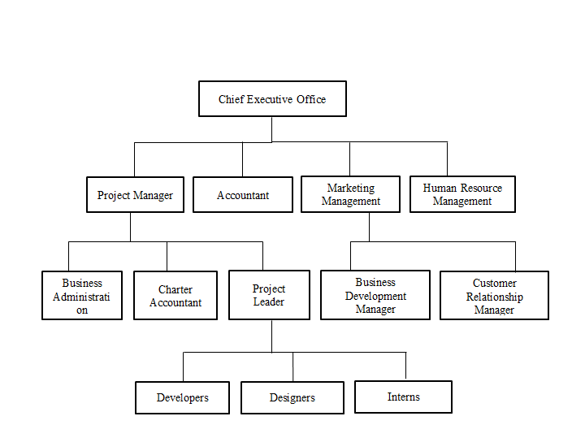

Figure 1:NextStep Organization Structure

## Working Domains of the Organization

As a IT company, NextStep likely operates in several working domain related to IT related works, including:

1. **Mobile App Development:** This domain involves the development of mobile applications for both IOS and Android platform. This may include using framework such as Flutter.
2. **Web Development and Visuals:** This domain involves the development of websites and web-based applications using languages such as JavaScript, HTML, and CSS. This also include the visuals and photography services.
3. **Graphic Designing and Animation:** This domain involves Graphic designing activities such as logo, banner designing, UI/UX designing poster designing and other type of designing using photoshop, coreldraw and adobe illustration.
4. **Digital sales and Marketing:** This domain involves in Digital marketing and branding of the various clients or organization and sales IT related products through online.

# 

## Description of intern Department/Unit

The internship period was 3 months, which was completed under the supervision of the allocated supervisor. Responsibilities were assigned to each individual according to the sprint. The actions were coordinated using priority and urgency. The highest-priority job is then selected first. As a Web app developer, the responsibilities included the following:

Implementing responsive design principles to ensure the application works seamlessly across various devices and screen sizes.

* Integrating back-end functionality and database management to ensure smooth data flow and storage.
* Implementing features such as vehicle management, route optimization, transaction processing, and data synchronization.
* Ensuring data validation and integrity to prevent errors, inconsistencies.
* Working closely with back-end developers, database administrators, and other team members to integrate front-end and back-end components seamlessly.
* Collaborating with the development team to ensure the application is delivered on time and meets the project requirements.
* Using version control systems (e.g., Git) to manage code changes, collaborate with team members, and track project progress.
* Documenting the codebase, including comments, documentation files, and technical documentation, to ensure clarity for future development and maintenance.
* Staying updated with the latest web development trends, technologies, and best practices.
* Adapting to changing project requirements and incorporating feedback from team members .
* Analyzing complex technical challenges and finding innovative solutions to ensure the functionality, security, and performance of the web application.
* Keeping up to date with the latest trends and best practices in mobile app development and Flutter framework, and contributing to the development of technical documents or project reports.

## Mission of Next Step

Mission:

**"To empower individuals and organizations with cutting-edge software solutions and digital strategies that drive growth and efficiency”.**

NEXT STEP is dedicated to delivering high-quality software development services, fostering innovation, and enabling our clients to thrive in the digital landscape."

## Vision of Next Step

Vision:

**"To be a recognized leader in the software development industry, setting new standards of excellence through innovative solutions and unwavering commitment to client success”.**

We aspire to make a global impact by redefining the possibilities of software and technology, while building enduring partnerships that drive mutual growth."

These mission and vision statements for NEXT STEP emphasize the organization's commitment to delivering innovative software solutions, fostering excellence, and achieving recognition as a leader in the industry. They also reflect the organization's dedication to client success and a global perspective.

# Internship of the Organization

## Role and Responsibilities

During the internship period, I became acquainted with the organization's working culture and had the opportunity to apply my theoretical skills in a practical setting. The company's working environment was highly conducive, providing a professional learning experience that significantly contributed to the enhancement of my skills, knowledge, and ability to work effectively in a team.

Collaborating with experienced professionals during this internship has boosted my confidence and contributed to my personal growth. Additionally, I acquired proficiency in the use of various tools and techniques, which proved invaluable in my professional development within the respective sector.

The following are all the activities and responsibilities that had been performed in the internship period:

• Familiarizing with the organization's workflow, team dynamics, and existing technologies

• Collaborating with the team to execute assigned tasks, adhering to project timelines and objectives.

• Participating in code development, debugging, and troubleshooting under the guidance of mentors.

• Applying theoretical knowledge to implement specific technologies, frameworks, or tools relevant to the project's requirements.

• Exploring and integrating components of Spring Boot, such as RESTful APIs, data persistence, and security mechanisms.

• Engaging in code reviews and discussions to ensure code quality, readability, and adherence to coding standards.

• Contributing to codebase enhancements, optimization, and refactoring based on feedback.

• Actively participating in team meetings, discussions, and knowledge-sharing sessions.

• Effectively communicating progress, challenges, and ideas to peers and mentors.

• Identifying technical challenges and actively seeking solutions through research and consultation.

• Continuously learning and adapting to new technologies, methodologies, and best practices.

• The intern's role is dynamic, encompassing not only specific technical tasks but also a holistic engagement with the organization's development processes and collaborative culture. Through active participation, the intern contributes to the successful execution of the project and gains valuable insights into professional software development practices.

## Weekly Log

**Week 1:**

Interview with the company and discussed the working environment**.**

Introduced to the project's objectives, scope, and technology stack.

Set up the development environment with Swing and related tools.

Conducted initial research on Swing fundamentals and GUI design principles**.**

**Week 2:**

Worked on improving the UI of the registration page using Spring MVC.

Implemented client-side validation for registration form input fields.

Explored Hibernate object-relational mapping (ORM) concepts and configured entity mappings.

**Week 3:**

Collaborated with team members to design the home page of the web application.

Integrated Spring Security for user authentication and role-based access control.

Improved the performance of the application by optimizing database queries using Hibernate.

**Week 4:**

Participated in team discussions on project requirements and use case scenarios.

Collaborated with senior developers to design a RESTful API schema.

Integrated Spring Data JPA to manage and query.

**Week 5:**

Integrated Hibernate Validator for server-side form validation.

Implemented automatic generation of bill numbers for installment registration.

Worked on the backend logic to validate and process installment payment details.

**Week 6:**

Worked on improving user experience by enhancing error handling and feedback messages.

Implemented cascading dropdowns for selecting vehicle type and automatically populating vehicle numbers.

Added server-side validation for installment registration and improved data integrity.

**Week 7:**

Successfully coded and tested API endpoints for user authentication and registration.

Gained insights into the importance of secure authentication mechanisms.

**Week 8:**

Collaborated with team members to implement unit tests for critical functionalities.

Reviewed and provided feedback on code written by peers.

Addressed bugs and performed debugging to enhance application reliability.

**Week 9:**

Integrated Hibernate second-level cache to optimize data retrieval.

Added integration with external APIs for fetching vehicle-related data.

Implemented feature to display selected vehicle's details based on chosen vehicle number.

**Week 10:**

Attended a session on advanced Spring Boot features and best practices.

Conducted comprehensive testing of installment registration, including validation and automatic bill number generation.

Collaborated with the team to address any outstanding issues and enhance user experience.

**Week 11:**

Conducted interviews with potential users to gather feedback on the application's usability and performance.

Utilized Postman and ngrok for testing API endpoints and ensuring seamless integration.

Refined the application's UI based on user feedback and conducted further testing to address any usability issues.

**Week 12:**

Continued to refine and optimize the application's performance, focusing on speed and responsiveness.

Implemented additional security measures, including input validation and data encryption.

Finalized the project documentation, including user guides and technical documentation for future development.

## Description of the project involved during Internship

### Introduction to Project

The project undertaken during the internship centered on the development of a dynamic and user-centric web application leveraging the Java Spring Boot framework. The primary goal of the project was to create a robust and intuitive platform that streamlines the process of vehicle installment registration and management for a diverse range of users, offering enhanced convenience and efficiency.

Design a user-friendly interface allowing users to effortlessly register vehicle installment details while ensuring accurate and validated data entry. Implement a seamless mechanism for generating unique bill numbers automatically upon successful installment registration, eliminating the need for manual input.

Integrate server-side validation mechanisms to ensure the accuracy and consistency of registered data, minimizing errors and discrepancies. Utilize external APIs and database integration to retrieve comprehensive vehicle information based on the selected vehicle number and type. Develop an intuitive and responsive user interface that simplifies the registration process, validates user inputs, and provides informative feedback. Leverage Hibernate ORM capabilities for efficient and organized data management, including seamless interaction with the database.

### System Design

The system design phase of the project was a critical endeavor that laid the foundation for the successful implementation of the web application. The design process involved making strategic decisions regarding architecture, data flow, user interfaces, and integration with external resources. The overarching goal was to create a well-structured and scalable system that aligned with the project's objectives.

The Web app has the following components:

* User Interface: The User Interface component provides an intuitive and user-friendly platform for users to interact with the installment payment system. It includes various screens and features designed to enhance user experience.
* File Sharing Service: The File Sharing Service enables users to upload and share necessary files related to their installment payments.
* Messaging Service: The Messaging Service facilitates real-time communication between users and the system administrators.
* Authentication Service: The Authentication Service ensures secure access to the installment payment system.
* Data Storage Service: The Data Storage Service manages the storage and retrieval of user-related data.

### Tools and Technologies Used

Some of the tools and technologies in Web app development with Spring Framework:

* Spring Boot Framework: Spring Boot forms the foundation of the web application, providing a framework for rapid development and deployment of Java-based applications. It offers features such as auto-configuration, embedded servers, and production-ready templates, streamlining development efforts and ensuring the application's stability.
* ORM: Hibernate, a powerful Object-Relational Mapping (ORM) tool, facilitates seamless interaction between Java objects and relational databases. It simplifies database operations, such as data retrieval and manipulation, by mapping Java classes to database tables, thereby minimizing the need for manual SQL queries.
* Spring MVC (Model-View-Controller):

The Spring MVC architectural pattern divides the application into distinct components—Model, View, and Controller—enhancing maintainability and modularity. It facilitates the separation of concerns, allowing developers to focus on specific aspects of the application.

* Spring Data JPA:
* Spring Data JPA simplifies database interactions by providing a repository abstraction layer. It automates the creation of repository implementations, relieving developers from writing boilerplate data access code.
* Web Server (e.g., Apache Tomcat):

A web server is required to deploy and host the Spring Boot application, making it accessible to users.

* Web Browser:

Web browsers are used to interact with and test the application's user interface and functionalities.

* Version Control (e.g., Git):

Version control systems enable collaborative development and efficient management of code changes.

* Integrated Development Environment (IDE):

IDEs like IntelliJ IDEA or Eclipse provide a comprehensive environment for coding, debugging, and testing Spring Boot applications.

The strategic utilization of these tools and technologies ensures the successful implementation of the installment payment web application. By harnessing the capabilities of Spring Boot, Hibernate, and other complementary technologies, the application offers a secure, efficient, and user-centric platform for managing installment payments seamlessly.

## Tasks/Activities Performed

During the course of the internship, a series of tasks and activities were undertaken to develop and enhance the installment payment web application using the Spring Boot framework. The following outlines the significant tasks and activities performed throughout the internship:

**Requirement Analysis:** Conducted a thorough analysis of the project requirements to gain a comprehensive understanding of the goals, functionalities, and user expectations of the installment payment system.

Technology Selection: Chose appropriate technologies, including Spring Boot, Hibernate, and MVC architecture, based on project requirements and industry best practices.

**Environment Setup:** Set up the development environment with the chosen IDE, integrated build tools, and configured the Spring Boot application.

**Database Design**: Designed the database schema, including entities for customers, installments, payments, and associated relationships.

**Entity Mapping with Hibernate:** Utilized Hibernate annotations to establish mappings between Java entities and database tables, ensuring seamless data persistence.

**Controller Development:** Developed Spring MVC controllers to handle user requests, validate inputs, and manage interactions between the user interface and the backend. Throughout the internship, the performed tasks and activities revolved around conceptualizing, designing, developing, and refining the installment payment web application using Spring Boot, Hibernate, and the MVC architecture. The comprehensive approach ensured the creation of a feature-rich, user-friendly, and robust platform for managing installment payments effectively.

# Conclusion and Learning Outcomes

## Conclusion

All in all, during the internship program the author was able to gain the insights onto the IT industry and the real-world working environment. The knowledge gained throughout the four years of the academia has been fruitful during this internship period for the author. The author considered it as the golden opportunity to be able to get exposed to the IT industry and the author is forever grateful to have been able to work at such a reputed company.

Working at Next Step, provides me a great opportunity to enhance knowledge and skill that I have learnt in college. I got a chance to involve in a real-world task and most importantly work in team. Internship is a formal program that is performed within an organization whose primary goal is to offer practical work experience in a particular task to people who are totally new in that field. Internship program provides opportunity to understand the industry and know how the work is actually done.

## Learning Outcomes

The journey of developing the installment payment web application using Spring Boot, Hibernate, and the MVC architecture has been a valuable and enriching experience.

Through hands-on development, a deep understanding of the Spring Boot framework was acquired. This encompassed its auto-configuration capabilities, data access features, and integration with various components The project highlighted the importance of Hibernate in streamlining database interactions. Gaining proficiency in mapping Java entities to database tables and employing Hibernate annotations was a significant learning outcome.

Implementing the MVC architectural pattern reinforced the significance of separating concerns and creating modular components. This approach led to improved code organization, maintainability, and scalability. Collaborating within a team and participating in code reviews facilitated knowledge sharing, constructive feedback, and enhanced coding practices. Navigating challenges during development enhanced problem-solving skills and honed the ability to debug and resolve issues effectively. The iterative development process reinforced the principle of continuous improvement, emphasizing the value of incorporating feedback and making enhancements over time.

During my internship, I received feedback and mentor ship from my supervisor or other experienced professionals. This feedback had helped me to identify areas for improvement and continue to develop my skills even after the internship is over.

Overall, my Spring framework internship was likely a valuable experience that helped me to develop new skills, gain practical experience, and prepare for a career in mobile app development..

References

Baeldung. (2023, June 18). JPA. Retrieved from Learn Spring Data JPA course: https://www.baeldung.com/learn-jpa-hibernate

Baeldung. (2023, June 30). Get started with Spring 5 and Spring Boot 2. Retrieved from Spring Boot: https://www.baeldung.com/spring-boot

Javatpoint Logo. (n.d.). Spring Tutorial. Retrieved from https://www.javatpoint.com/spring-tutorial

Aryal, M. (2023, August 25). A Very Short History Of Information Technology In Nepal. Retrieved from ictframe: https://ictframe.com/a-very-short-history-of-information-technology-in-nepal/

Edusanjal. (2023, August 15). Bachelor in Information Management. Retrieved from edusanjal: https://edusanjal.com/course/bachelor-of-information-management-bim-tribhuvan university/

Hamrodevjobs. (2023, August 25). 6 Common Challenges Faced By IT Startups In Nepal. Retrieved from hamrodevjobs: https://hamrodevjobs.com/blog/6-Common-Challenges-Faced-By-IT-Startups-In-Nepal

Jobaxle. (2023, September 20). IT Scope in Nepal. Retrieved from jobaxle: https://jobaxle.com/blog_detail/it-scope-in-nepal/64#:~:text=IT%20professionals%20in%20Nepal%20have%2C%20telecommunication%20companies%2C%20and%20many%20others.

# Appendix

Screenshots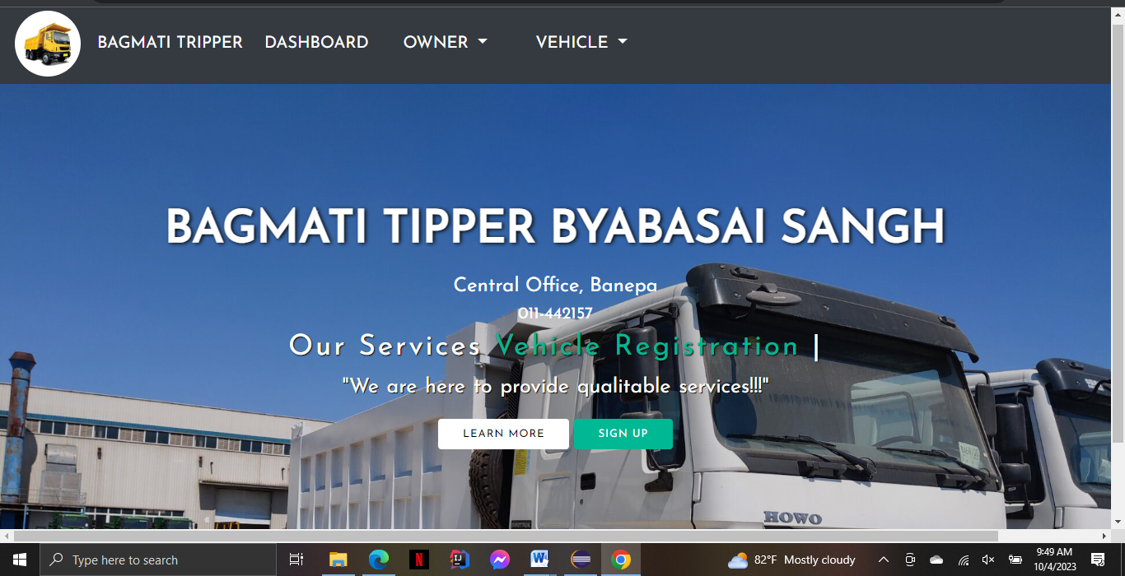

Figure 2:Bagmati_Tipper WebApp

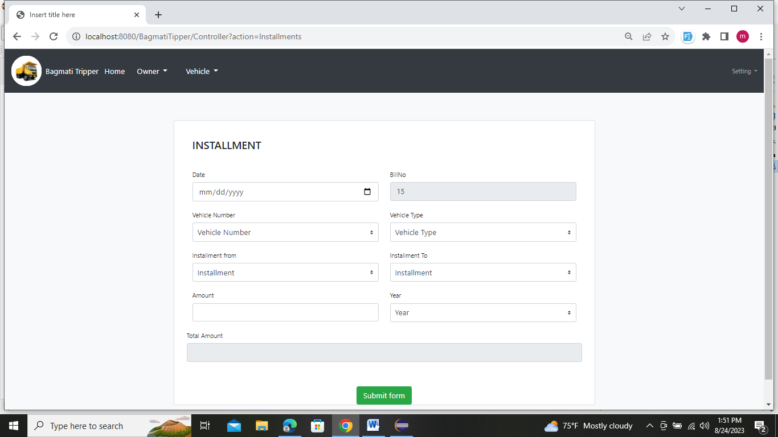

Figure 3:Installment page

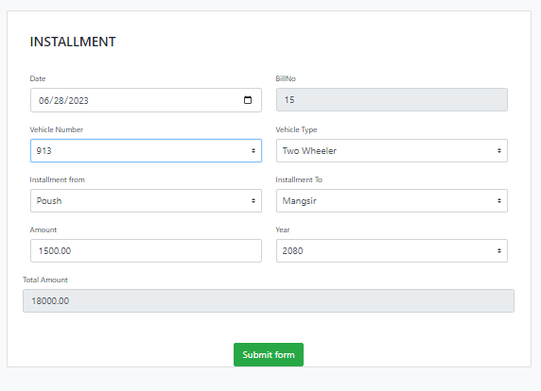

Figure 4:Installment FillOut page

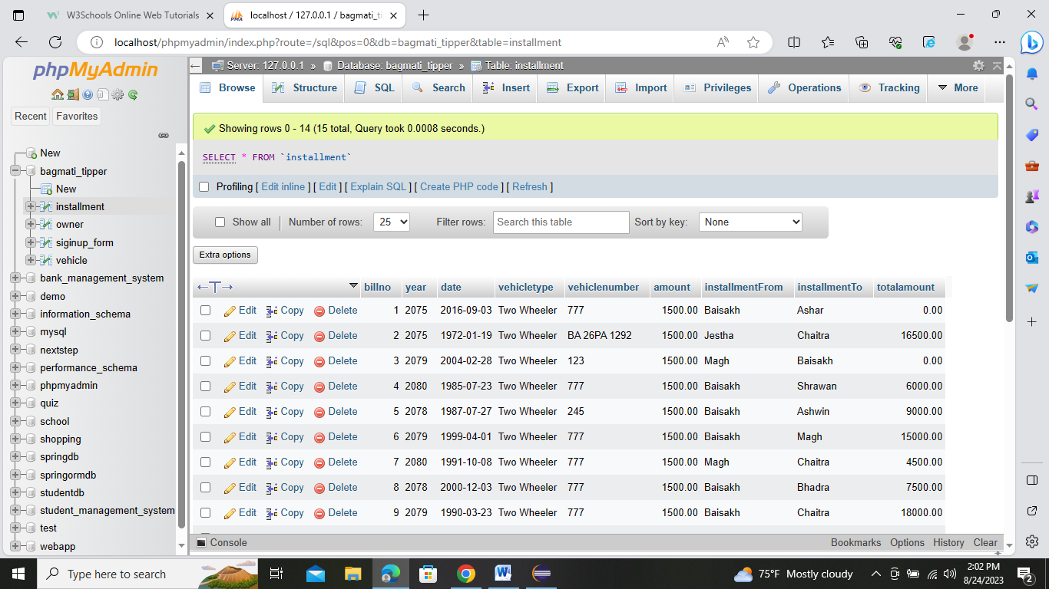

Figure 5:DataBase For Installment

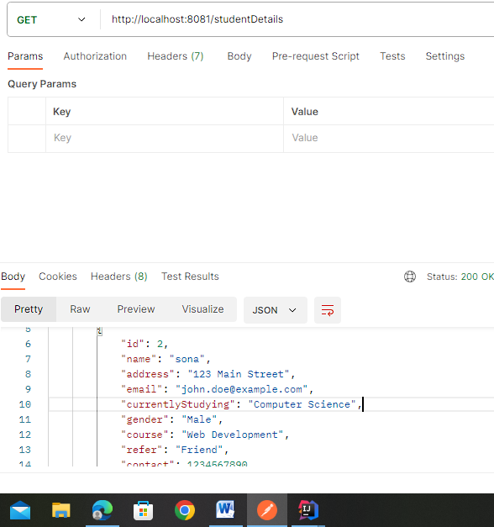

Figure 6: Postman(GET)Method

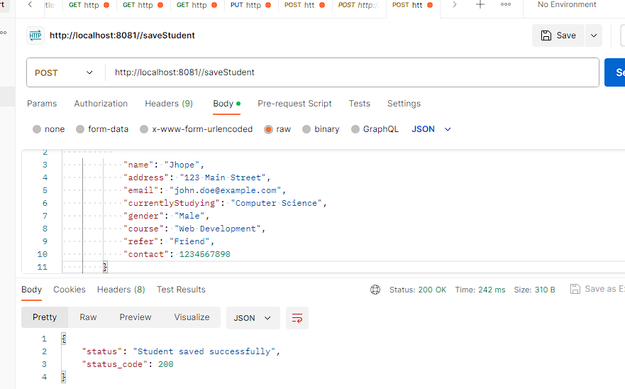

Figure 7: Postman(POST)Method

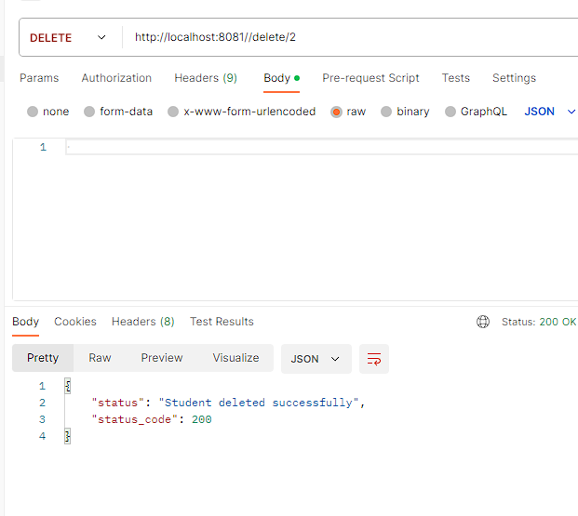

Figure 8: Postman(DELETE) Method

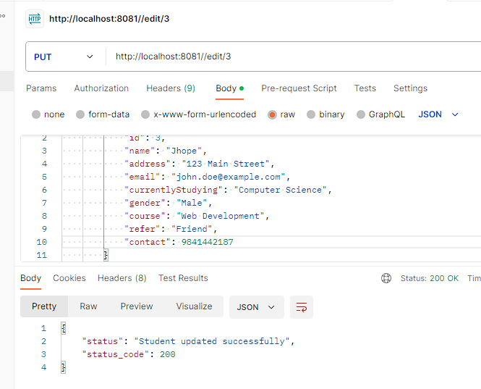

Figure 9: :Postman(Put)Method

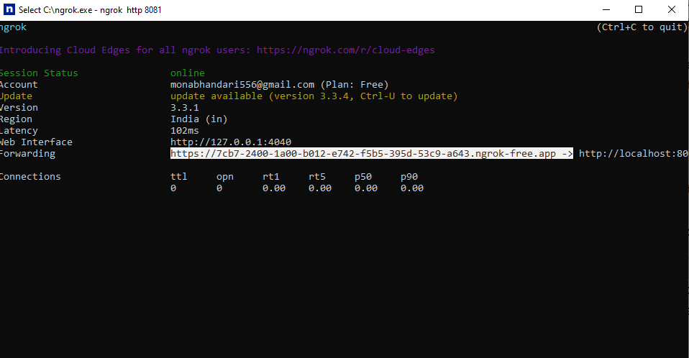

Figure 10: Ngrok



Figure 11: Quiz getting started with Loader( Demo Project )

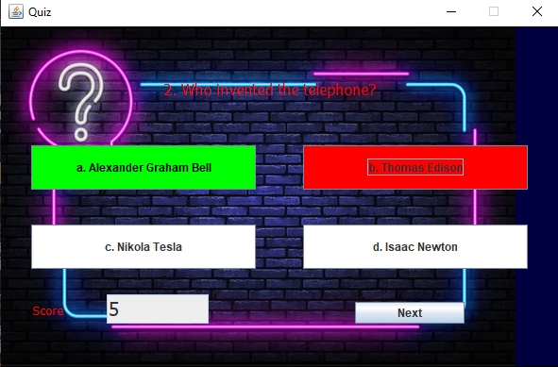

Figure 12: :Quiz started



Figure 13:Final result of quiz